My progress: keeping as active and independent as I can

My name is:

What can I do to be even more active?

Why being active is important to
me:

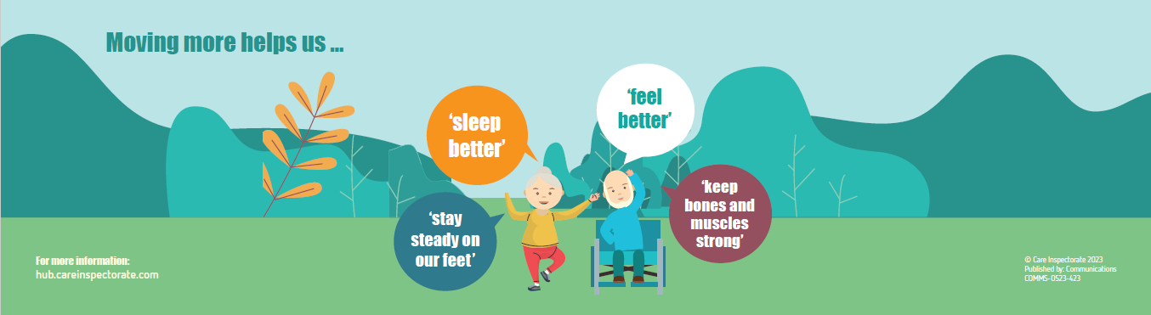
Progress: Use this sheet to track how you are getting on.
This can also be helpful as you build back your abilities after a spell in hospital.
Name of activity or goal: | The date I started: | How I am getting on:

What I am pleased with about my progress:

What would be even better:



