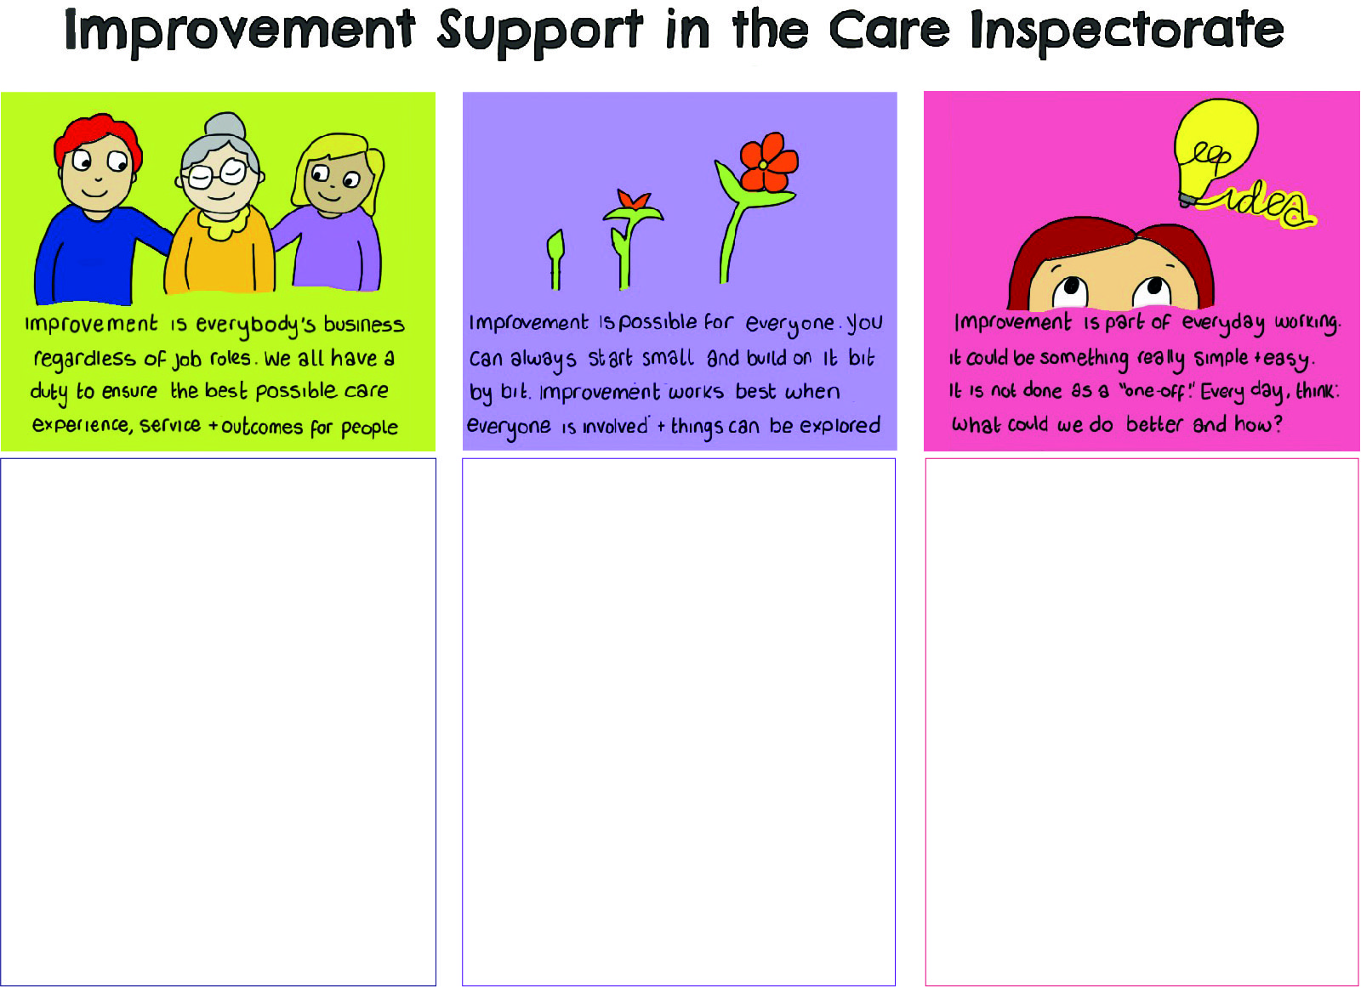
Open badges
Sharing your Improvement Journey
Open badges are a way of recognising your learning and provide you with the opportunity to demonstrate your understanding through the writing of a reflective account. They can also contribute to your SSSC PRTL.
We have created a ‘story board’ approach to recording your improvement journey which will provide a framework to summarise your work within our Learning Communities.

Why record your Improvement Story?
- Everyone benefits when we share learning and experiences!
- You could inspire others to think about their improvement ideas and giving them confidence to make a change in their service.
- You can show that small changes can make a positive impact to the lives of people you work with.
- You can share lessons learned from you experience so that others can gain from your ideas and solutions.

Your improvement story
Recording your progress as an improvement story will allow you to reflect on your work. It will record the process you went through and help others see exactly what the issue was, why it needed to be sorted, how you went about doing it and the difference it made.

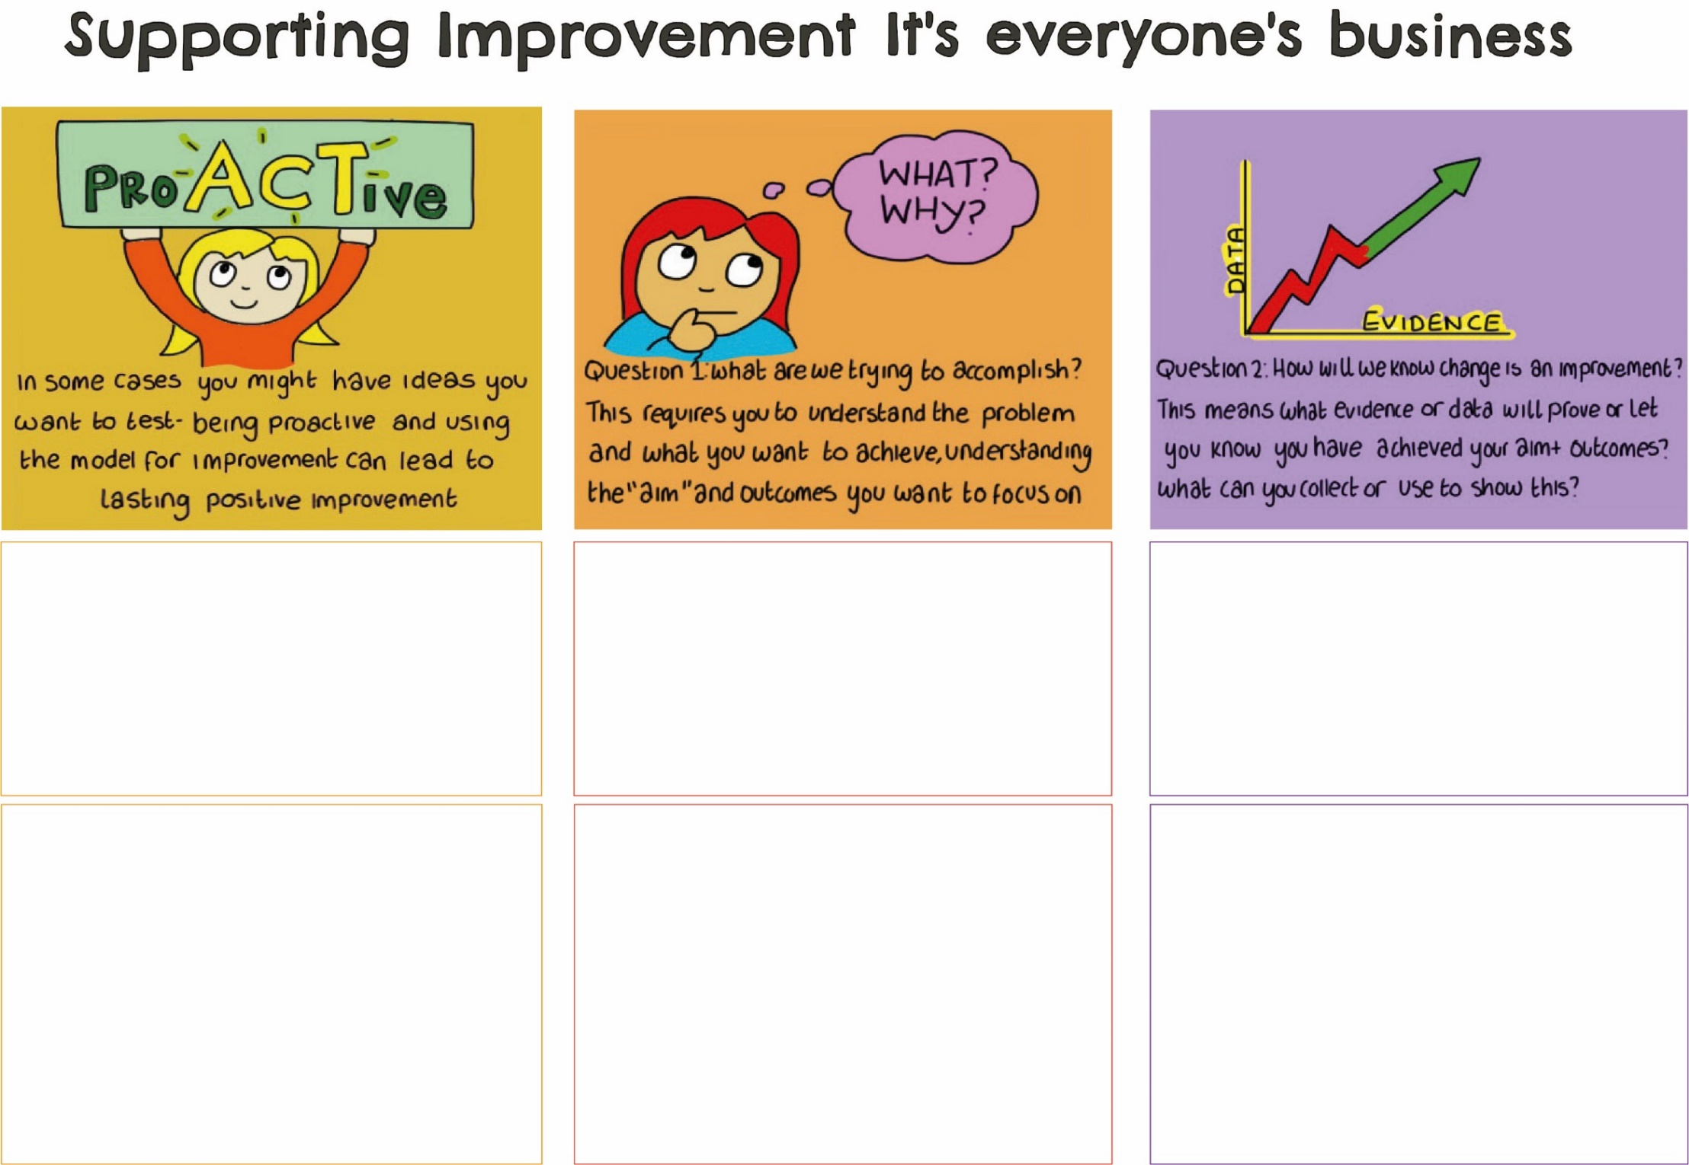
Where did you start?
What was the problem and what did you want to change? How was the problem/issue identified and why was it important to sort it out?

What did you do?
What did you do to tackle the problem, how did you do it and who did you ask for help? Was there a reason you decided to tackle the problem in this way?

How do you know you made a difference?
Measuring the changes means you can prove that what you did made a difference. So, what did you measure to show an improvement and how did it change? How did it make a difference?

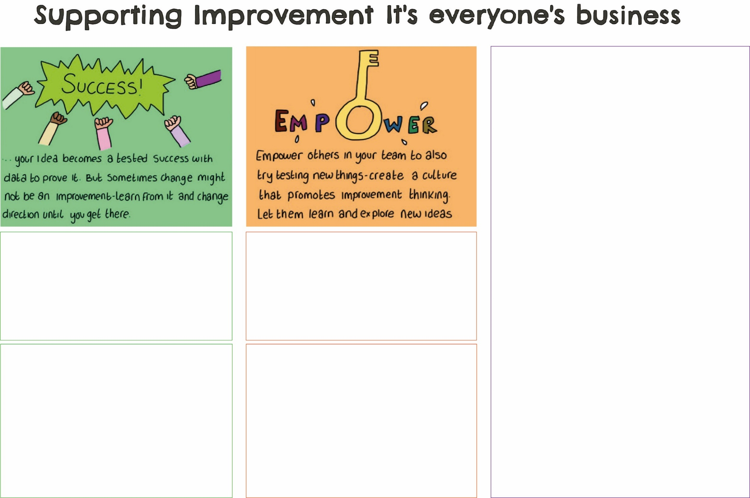
What did you learn from the experience?
Reflecting on what happened is important if you want to use this approach again. What went well? What would you maybe change next time? Is there anything you are really pleased about? How did you keep going?

How are you going to keep this going?
This is the ‘what next’ question! Now that you’ve made a positive change, how are you going to keep it going, and are there things you can now do to build on this? Did you share this experience with others both in your service and beyond?

NOTES

