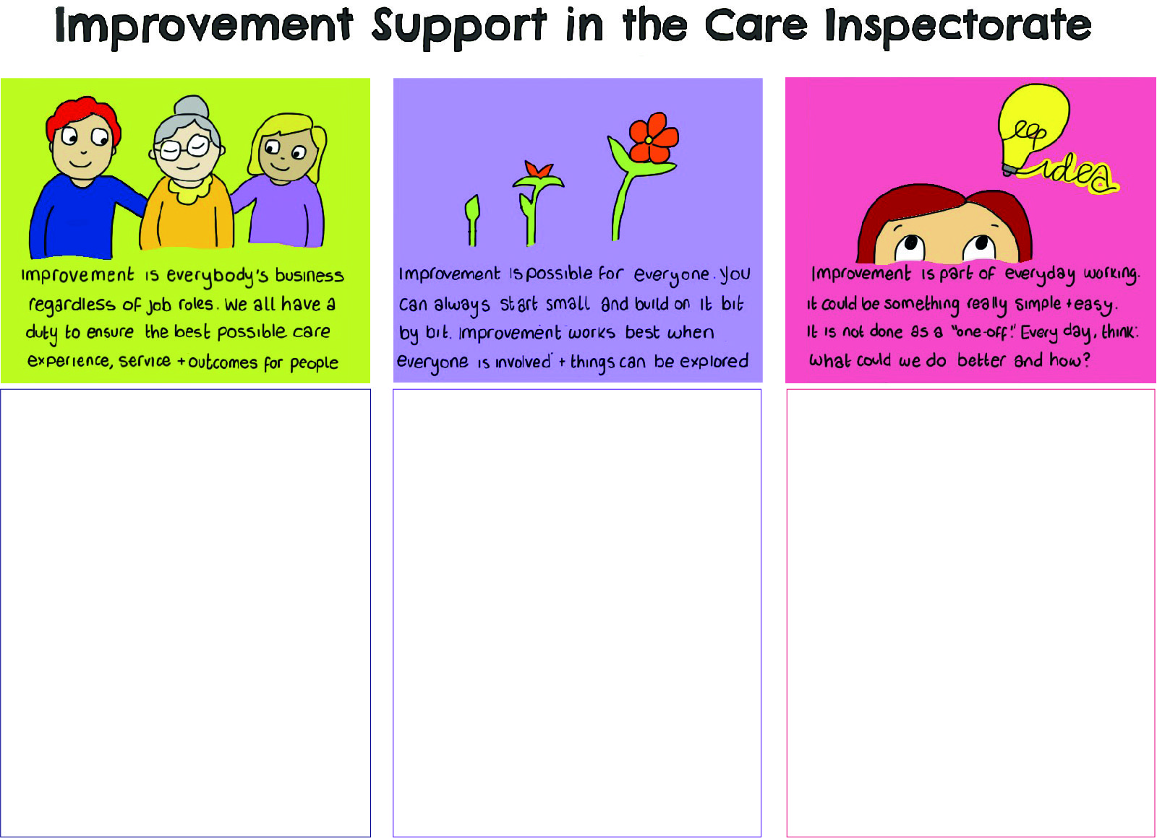
Sharing your Improvement Story
Have you made a change in your service that has made a difference to people who use your service?
Maybe you’ve approached a problem or issue by trying something new which has made a positive impact.
Has the process of inspection, registration or complaints identified an area for improvement that you have worked on?
If you have a story to tell, we would like to hear about it so that it can be shared with others.

Why share your Improvement Story?
- Everyone benefits when we share learning and experiences!
- You could inspire others to think about their improvement ideas and giving them confidence to make a change in their service.
- You can show that small changes can make a positive impact to the lives of people you work with.
- You can share lessons learned from you experience so that others can gain from your ideas and solutions.

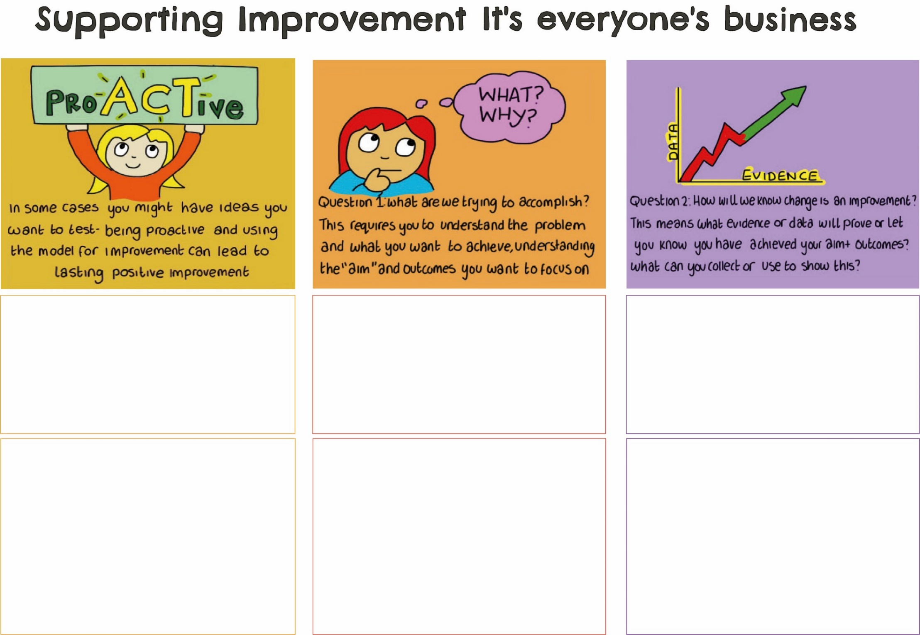
Where did you start?
What was the problem and what did you want to change? Why was it important to sort it out?

What did you do?
What did you do to tackle the problem, how did you do it and who did you ask for help? Was there a reason you decided to tackle the problem in this way?

How do you know you made a difference?
Measuring the changes means you can prove that what you did made a difference. So, what did you measure to show an improvement and how did it change? How did it make a difference to those experiencing care?

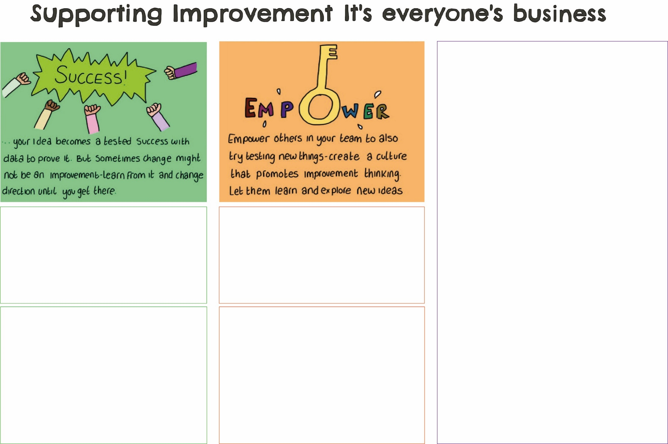
What did you learn from the experience?
Reflecting on what happened is important if you want to use this approach again. What went well? What would you maybe change next time? Is there anything you are really pleased about? How did you keep going?

How are you going to keep this going?
This is the ‘what next’ question! Now that you’ve made a positive change, how are you going to keep it going, and are there things you can now do to build on this? Did you share this experience with others in your service?

NOTES

